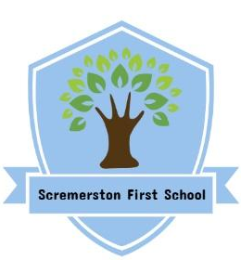
Scremerston First School Weekly Newsletter
3rd May 24

This week’s question of the week for discussion at home…How can shops make sure everyone feels represented?

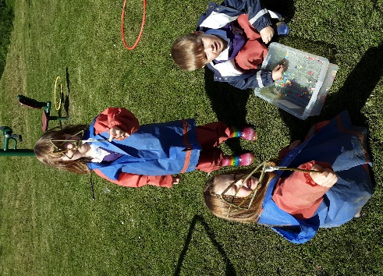
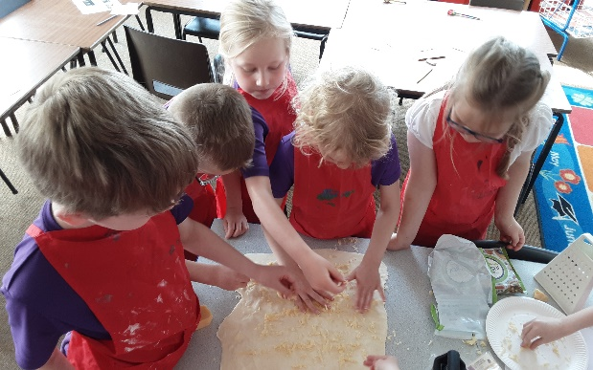
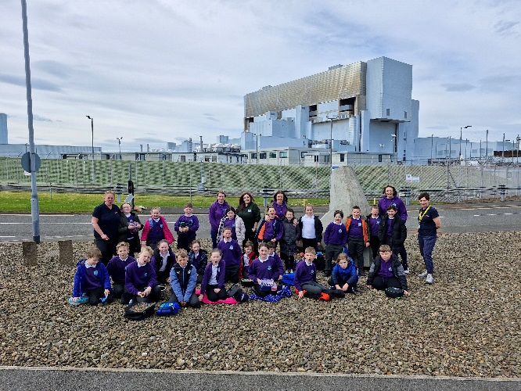
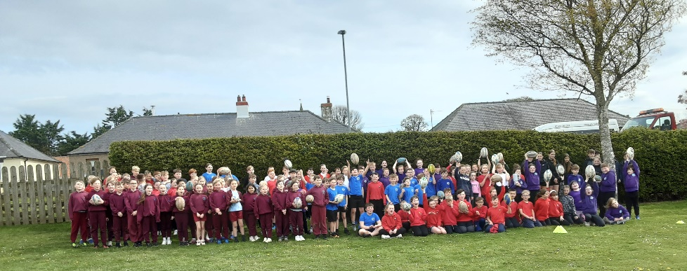
This week in photos…

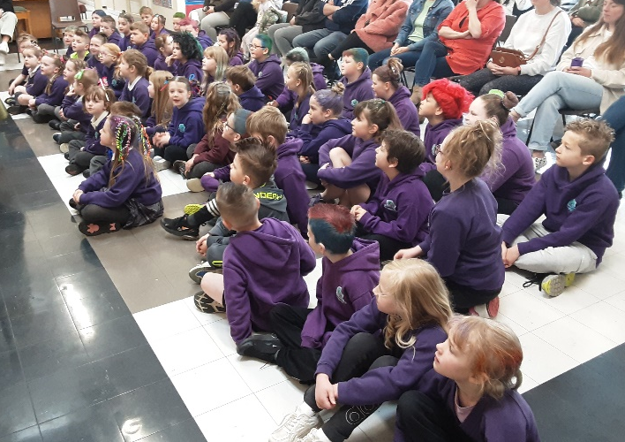
What a busy week we have had this week! Starting with hosting a Key Stage 2 Rugby Festival on Monday with other Berwick first schools taking part, Ash class trip to Torness on Tuesday, Elm class trip to The Hirsel on Wednesday and other activities in school like baking and forest school! Everyone made a fabulous effort for Crazy Hair day today too! Making learning fun and memorable!

Thank you to those who were able to donate for Crazy Hair Day! We have raised a wonderful £50.51, which will go into the trips pot!

Dates for your Diary
Mon 6th May - BANK HOLIDAY - School Closed
Wed 8th May - Y4 Residential trip to Ford Castle Wed - Fri
Mon 13th May - Oak class trip to The Hirsel
Tue 14th May - Mr Skippy - Ash class
Fri 24th May - Dress down day - tombola donations welcome

Star Of The Week Awards

Angus & Lottie
For being great talk partners and sharing their learning!

Archie
For super behaviour, listening and effort this week!

Kobe
For explaining his understanding to tricky concepts, articulately and confidently!

Super Work Of The Week Awards

Lottie & Sierra
For consistently good effort with homework!

George
For his work on grouping, sharing & arrays in maths!
Violet
For super predictions using new vocabulary that we have been learning!

Elena-Mai
For great understanding of equivalent fractions!
Matthew
For creating detail and texture when sculpting his dragon eye!

Well Done Everyone!!

