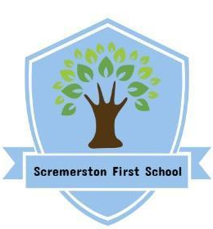
Scremerston First School Weekly Newsletter
19th April 2024

This week’s question of the week for discussion at home…What does art mean to you?

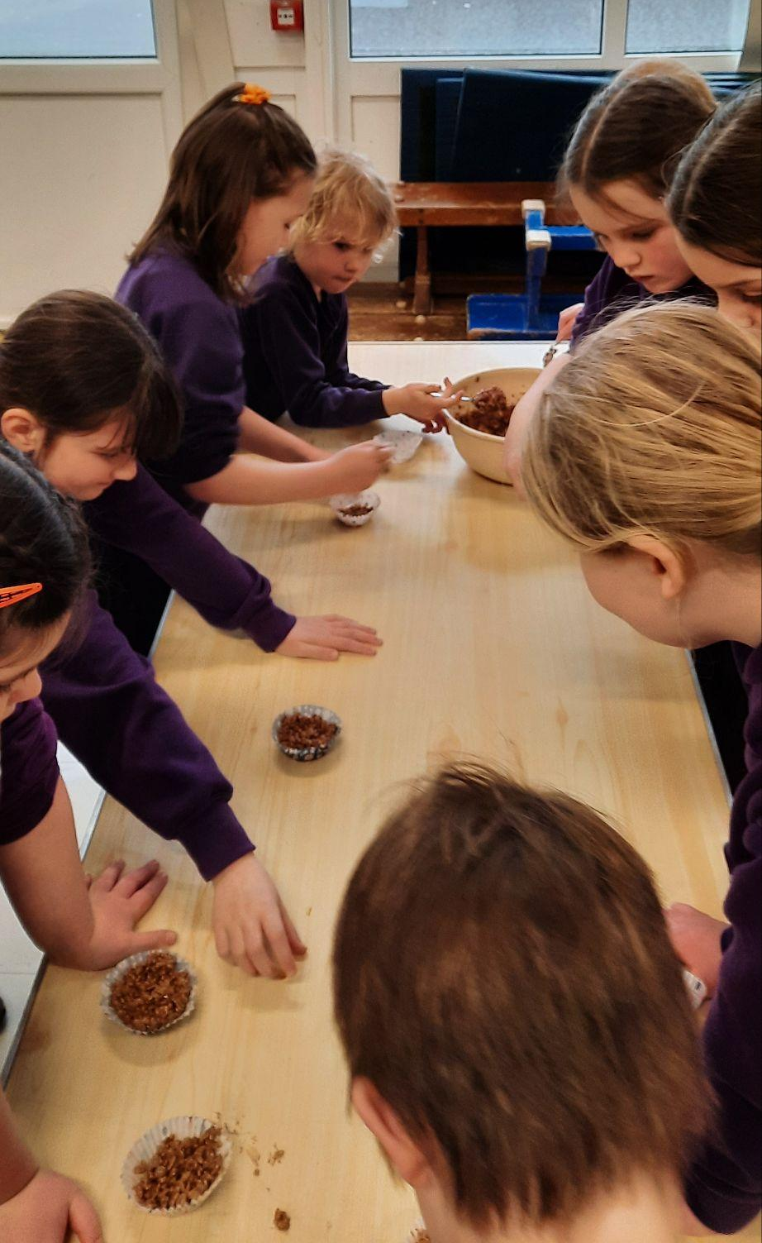
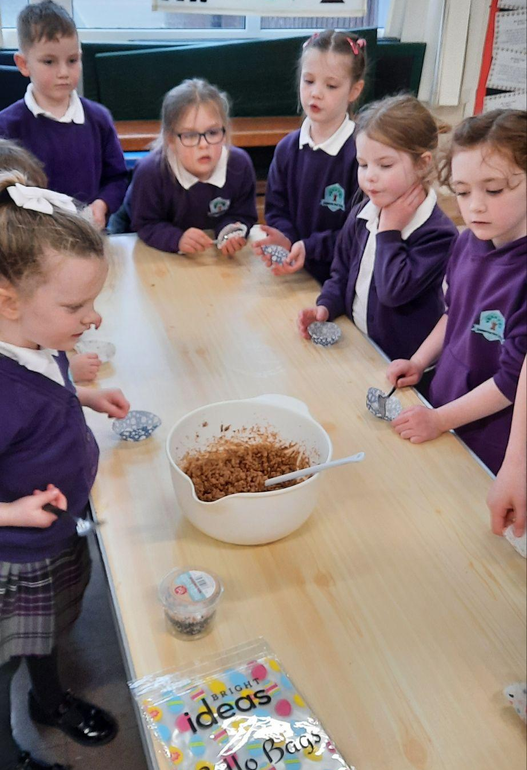
Reader’s Treat
Our children who collected at least 9 points for their reading at home last term, enjoyed making some Easter treats before the holidays!

This term the children will receive a raffle ticket each week they manage 4 reads at home.

At the end of each half term, one child from each year group will receive a reward at random by a raffle ticket being drawn.
The more raffle tickets your child can accumulate the more chance they have to win!
Reminders
- Photo orders are to be back to school by Tuesday 23rd April.
- Y4 Ford consent/medical forms should be completed and returned by Wed 24th April.
- School staff are only contactable during school hours 8am - 4pm, Monday - Friday so if you contact them outside of these hours you may have to wait for a response.

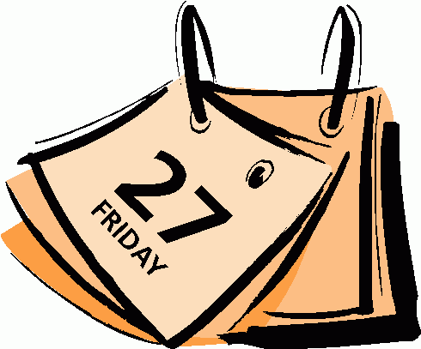
Dates for your Diary

Tue 23rd April - BMS Dodgeball for Y4 children moving to BMS in Sept
Mon 29th April - Rugby Festival for Ash class & other schools (Ash class to wear PE Kit)
Tue 30th April - Ash class visit to Torness (Full school uniform to be worn)
Wed 1st May - Elm class trip to The Hirsel
Mon 6th May - BANK HOLIDAY - School Closed
Wed 8th May - Y4 Residential trip to Ford Castle Wed - Fri
Mon 13th May - Oak class trip to The Hirsel

Star Of The Week Awards

Angus
For his progress with independent writing!

Molly
For her fantastic effort in phonics and reading!

Jessica J
For knowing what she needs to do to improve and setting her mind to it and having a fantastic attitude!

Super Work Of The Week Awards

Sophie
For confidently building numbers to 20 using tens frames!

Emily B
For her fantastic, independent diary writing!
Hannah
For her hard work practising and improving her handwriting!

Betsy
For carefully examining artefacts from Sutton Hoo to tell us more about Anglo Saxon life!
Emily S
For confidently completing all chilli challenges in our fractions work!

Well Done Everyone!!

